
2016 Mazda 2.5L Turbo Skyactiv-G Engine Tested with Tier 2 Fuel – NCAT Test Report

SUGGESTED CITATION: 2016 Mazda 2.5L Turbo Skyactiv-G Engine Tier 2 Fuel – Test Data Package. Version 2019-02. Ann Arbor, MI: US EPA, National Vehicle and Fuel Emissions Laboratory, National Center for Advanced Technology, 2019.

NCAT – National Center for Advanced Technology

National Vehicle and Fuel Emissions Laboratory – Office of Transportation and Air Quality
U.S. Environmental Protection Agency

March 13, 2019

Mark Stuhldreher

Version: 03-13-19

Table of Contents
Purpose of Test 3
Definitions 3
Description of Test Article 3
Test Site 3
Test Cell Capabilities 4
Data Collection Systems 4
Vehicle Tethering 5
Engine Setup 6
Engine-Dynamometer Setup 7
Test Methodology 8
Test Fuel 8
Quality Procedures 9
Engine Safeties 9
Pre-Conditioning and Common Mode Check 10
Data Set Definition 10
Test Cell Procedures 10
Test Data Collection and Analysis 11
Benchmarking Details………………………………………………………………………….12
Test Phase 1: Low-Mid Loading……………………………………………………………….13
Test Phase 2: High Loading……………………………………………………………………14
Special Measurement of Fuel Consumption During Transient Operation……………………...17
Test Phase 3: Idle-Low Speed………………………………………………………………….18
Data Quality Control 19
Results 19
Uncertainty 212
References 27

Purpose of Test
The purpose of this test is to characterize the performance of a 2016 Mazda CX9 2.5L Turbo Skyactiv-G engine and generate fuel map data that may be used in the ALPHA full vehicle simulation model. During the course of this testing, test methods for use in characterizations of future engines were also developed.

Definitions
Fuel map | Engine operating map that displays contours of brake specific fuel consumption (in g/kWh) on a grid of engine speeds (RPM) and engine torques (Nm)
Protection mode | An engine operation mode where the ECU retards ignition timing, limits load and/or runs excess fuel (λ<1) due to exhaust temperature limits being reached
ALPHA model | Advanced Light-Duty Powertrain and Hybrid Analysis tool

Description of Test Article
A 2016 Mazda CX9 vehicle with a 2.5L turbo direct-injection gasoline engine was selected for use in this testing. Table 1 describes the vehicle and powertrain used in this test program.

Table 1: Summary of Vehicle and Engine Identification Information
Vehicle (MY, Make, Model) | 2016 Mazda CX9
Vehicle Identification Number | JM3TCABYXG0104977
Engine (displacement, name) | 2.5L DOHC 16-Valve 4-Cylinder
Rated Power | 227 hp (169 kw) @ 5000 RPM
Rated Torque | 310 lb.-ft (420 Nm) @ 2000 RPM
Recommended Fuel | Regular unleaded E87
Engine Features of Interest for MTE | Direct-injection, Dynamic pressure turbocharger, dual variable valve timing (VVT)

Test Site
This test was performed in National Center for Advanced Technology (NCAT) Test Cell 9, but the procedure is applicable to any NCAT test cells using iTest controls and RPECS data collection.

Test Cell Capabilities
The following instrumentation, listed in Table 2, exists in Test Cell 9 although not all instrumentation listed may have been utilized during this testing.

Table 2: Instrumentation in NCAT Test Cell 9
Equipment / Instrument Name | Purpose/Measurement Capabilities | Manufacturer
Dynamometer | Absorb torque from engine and provide motoring torque to engine | Meidensha Corp.,  Tokyo, Japan
Torque Sensor | Measures torque | HBM GmbH,  Darmstadt, Germany
CVS Dilution Tunnel | Exhaust flow system | EPA
Coriolis Fuel Meter | Measures fuel flow rate | Emerson Micro Motion,  St. Louis, MO
Laminar Flow Element | Measures air flow rate | Meriam Process Technologies, Cleveland, OH

Data Collection Systems
Test cell data acquisition and dynamometer control were performed by iTest, a software package developed by A&D Technology, Inc., Combustion data were analyzed by an MTS Combustion Analysis System (CAS). RPECS-IV (Rapid Prototyping Electronic Control System - IV) is supplemental data acquisition software developed by Southwest Research Institute (SwRI). RPECS directly measures and logs ECU input/output (I/O) along with test cell data. Temperatures, pressures, and test cell data were sent from iTest to RPECS via CAN. The engine control and analysis systems are summarized in Table 3.

Table 3: Engine Control and Data Acquisition Systems
System | Developer | Description | Data Rate
iTest | A&D Technology Inc., Ann Arbor, MI | Test cell automation hardware and software system that controls the dynamometer and some engine controls; collects test cell data; master data logger. | 10-100 Hz
MATLAB | MathWorks, Natick, MA | Software used for development of data processing algorithms for transient testing | --
RPECS | Southwest Research Institute, San Antonio, TX | Crank angle-based engine control and data acquisition system that collects ECU analog and CAN data, TCU analog and CAN data, and controls torque converter lock up solenoid. | 1/engine cycle

Vehicle Tethering
The objective of this benchmarking was to characterize the engine while operating in an engine dynamometer test cell as though the engine were operating in the vehicle. The engine control unit (ECU) in today’s vehicles requires communication with other control modules to monitor the entire vehicle’s operation (security, entry, key on, dashboard signals, etc.). Because the ECU needs signals from these modules to operate, the signals need to be extended into the test cell, so the ECU can send and receive signals indicating correct vehicle operation. For this benchmark testing, the wiring harnesses were lengthened to connect (tether) the ECU in the test cell to the rest of the vehicle chassis located outside the cell. The ECU signals were monitored by the data acquisition system. Figure 1 illustrates the tethered wiring harness.

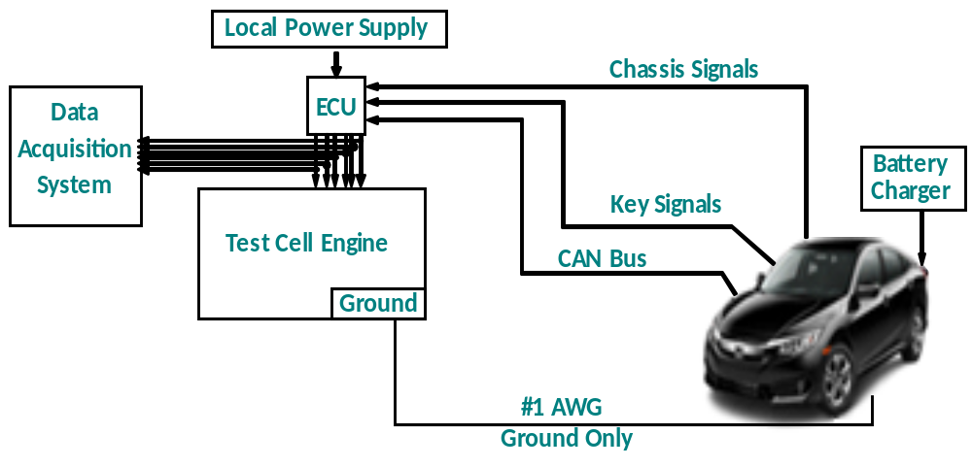
Figure 1. Vehicle and Engine Tethered Wire Harness

Engine Setup
Figure 2 illustrates the engine configuration and sensor location in the dynamometer test cell. The sensor colors shown in the upper left corner of the figure indicate which systems are monitored.
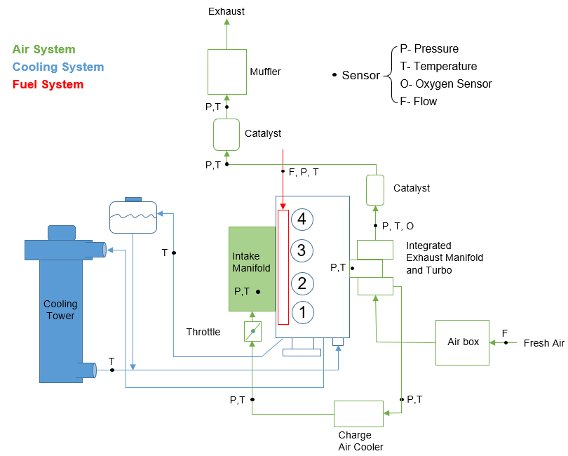
Figure 2: Schematic of Dynamometer Test Cell and the Engine Sensor Locations Corresponding to the Identified Systems
The stock engine systems were used with the addition of instrumentation as follows:
- Intake: The stock air box and plumbing were used with a laminar flow element (LFE) connected to air box inlet.
- Exhaust: The stock exhaust system was used including catalyst and mufflers (the figure only shows one muffler). The exhaust system outlet connected to the CVS emissions tunnel via 2-inch diameter tubing. Emission tunnel pressure was controlled to CFR specifications for chassis dynamometer testing (P^{atm} +/- 1.2 kPa).
- Cooling system: The stock cooling system was used, but the radiator was replaced with a cooling tower. The stock engine thermostat was used to control engine coolant temperature. The cooling tower was controlled to 85°C by the test cell control system.
- Oil system: The stock oil cooler was connected to a chilled water system and controlled to 90°C by the test cell control system.
- Charge air cooling: During testing, engine temperatures were maintained to a level representative of real-world use, where the engine would be cooled by airflow into the engine compartment as vehicle speed increases. On-road testing identified 30 to 40°C as the target intercooler air temperature range for the engine. In the test cell, air charge temperature was maintained at 30 to 40°C by using the stock intercooler sandwiched to a water-to-air heat exchanger and fans. The actual temperature for each sampled data point is recorded with each data point.
- Front End Accessory Drive (FEAD): The stock belt and water pump were used but no other accessory was driven.
- Alternator: No alternator was used.

Engine-Dynamometer Setup
To gather data for this benchmarking program, two methods of coupling the engine to the dynamometer were needed. Direct drive shaft engine to dynamometer coupling worked best to gather most of the data. However, when idling and operating in the low rpm region of the engine’s operating map (especially below 1000 rpm), the high torsional stiffness of the rigid driveshaft tends to not allow the testing to replicate how the engine operates in a vehicle. Consequently, the second method of coupling the engine to the dynamometer through an automatic transmission and torque converter is necessary for gathering data where the torque measurement is very sensitive to the engine’s torsional accelerations.
Direct Drive Shaft Setup - In this method, the engine was coupled to the dynamometer via a drive shaft. A flywheel was fabricated to couple the engine to the driveshaft. A single HBM torque sensor was mounted inline between the driveshaft and dynamometer. This setup was used for testing from 1500 to 5000 rpm.
Setup with an Automatic Transmission - In this method, the engine was coupled to the dynamometer via a drive shaft and through a General Motors 6L80 automatic transmission and torque converter with a torque sensor between the engine and transmission as shown in Figure 3. This engine setup allowed data to be gathered at low engine speed to compute engine idle fuel consumption and to start the engine using its starter to replicate starting behavior like the vehicle. The engine could also then operate at idle and low speeds with normal transmission loading and an unlocked torque converter. More complete details of this test and setup are in the attached SAE paper SAE 2017-01-5020 Testing and Benchmarking a 2014 GM Silverado 6L80 Six Speed Automatic Transmission. [1]

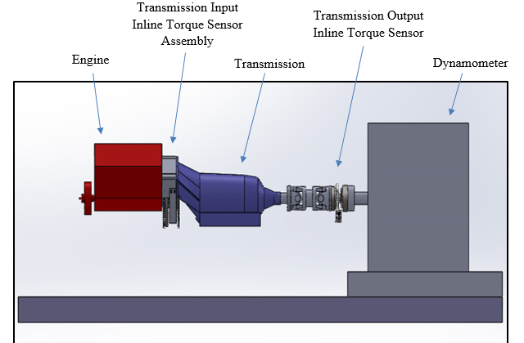
Figure 3: Engine and Transmission Setup with Torque Sensors

Special consideration for measuring torque - Special care is required for measuring engine torque and other sensors that are sensitive to engine cyclical dynamics. These signals become more sensitive when mounting the torque sensor between the engine and transmission as required for the engine setup used for this testing. When these sensors are sampled in a time domain at 100 Hz, signal aliasing occurs and distorts the reported signal values. These sensors cannot be correctly sampled at 100 Hz and must be sampled in the engine crank angle domain. The method consists of sampling the torque sensor output voltage with a high-speed data acquisition system, in this case RPECS, and averaging the samples over one engine cycle. The averaged value is then logged to iTest.

Test Methodology

Test Fuel
The primary properties of the Tier 2 fuel used in this test program are shown in Table 4 below. A detailed summary of the fuel analysis performed, and results measured for the Tier 2 fuel utilized in the test program can be found in the file: 6– NVFEL Fuel Analysis Report 26864.pdf.

Table 4. Fuel Properties for FTAG 26864
Parameter Description | Test Fuel Specifications  (40 CFR §86.113-04) | Reference Procedure | Measured Results | Units
Research Octane (optional) | 93 (minimum) | ASTM D2699; ASTM D2700 | 97.6 | RON
Octane Sensitivity (optional) | 7.5 | ASTM D2699; ASTM D2700 | 8.6 | RON-MON
Hydrocarbon Composition (vol %)
Olefins | 10% Maximum | ASTM D1319 | 0.6 | Vol %
Aromatics | 35% Maximum | ASTM D1319 | 30.2 | Vol %
Total Sulfur, wt.% | 0.0015-0.008 | ASTM D2622 | 40.0 | ppm
Dry Vapor Pressure Equivalent, psi (kPa) | 8.7–9.2 (60.0-63.4) | ASTM D5191 | 9.07 | psi
The following are provided for Reference Only and are not specified in the CFR
Antiknock | None | N/A | 93.3 | (RON+MON)/2
Net Heating Value | None | ASTM D3338 | 18447 | BTU/lb
Net Heating Value | None | N/A | 42.91 | MJ/kg
Alcohol Content | None | ASTM D5599 | 0.00 | Vol %
Carbon Content | None | ASTM D3343 | 0.86633 | Weight Fraction

Quality Procedures
This test program is covered by the Light-Duty Greenhouse Gas Test Program: Evaluating Potential Future Vehicle Technologies Quality Assurance Project Plan (QAPP).

Engine Safeties
Table 5 lists the limits that exist for several engine parameters. These variables were monitored to ensure component durability and operator safety.

Table 5: Engine Safety Limits
Parameter | Test Parameter Name | Units | Minimum | Maximum
Oil Pressure |  | kPa_{g} | 200
Coolant Temperature | Coolant Temp | ºC |  | 105
Engine Speed | Speed | RPM |  | 6500

Pre-Conditioning and Common Mode Check
Before testing began, the engine was allowed to warm up. The engine was considered “warm” when the fuel flow rate and exhaust temperatures stabilized, and the coolant and oil temperatures were a minimum of 90 ºC and 80 ºC respectfully. A common mode, run with the parameters given in Table 6, was repeated at the beginning of each test to expose any potential inconsistencies that could indicate equipment wear or improper instrument calibration.

Table 6: Common Mode Test Conditions and Criteria for Achieving “Warmed” State
Parameter | Test Parameter Name | Condition
Engine Speed Setting | Speed | 2000 RPM
Pedal Command Setting |  | 25%
Coolant Temperature Criteria | Coolant Temp | 90 ºC
Oil Temperature Criteria | Oil Sump Temp | 80 ºC

Data Set Definition
The data logged included torque, fuel flow, emissions, temperatures, pressures, in-cylinder pressure and OBD/epid CAN data. The steady-state data were recorded by the iTest data acquisition system. Each steady-state mode was logged to a single output file.

The final data set containing the engine mapping test parameters is provided in the test data file: 4- 2016 Mazda 2.5L Turbo Skyactiv-G Engine Tier 2 Fuel - Test Data. The data set includes a list of the test parameters along with the variable name, description, and calibration status. Variables that are listed “Reference Only” are not calibrated to a standard but are recorded to verify the correct operation of the engine to ensure the engine and ECU are operating without any faults or a check engine light. NCAT’s test data processor also uses this data set to produce the test data plots provided in the file: 5- 2016 Mazda 2.5L Turbo Skyactiv-G Engine Tier 2 Fuel - Test Data Plots.

Test Cell Procedures
The procedure for starting up and shutting down the test cell is outlined in the file: 3b- 2016 Mazda 2.5L Turbo Skyactiv-G Engine - Test Cell 9 Startup & Shutdown Procedure. This procedure describes how to activate and operate the test cell components required to run the engine. This procedure was developed during the installation of the engine and associated hardware needed for testing prior to conducting any recorded engine mapping and testing. This procedure ensures the correct start up and shutdown of the engine, the vehicle, and the test cell equipment for the engine to operate as expected in the test cell.

Test Data Collection and Analysis

Both steady-state and transient engine test data are collected during the benchmark testing. Two different test procedures are needed to appropriately replicate steady-state engine operation at low/mid loads and transient engine operation at high loads. NCAT’s benchmarking process gathers steady-state and transient test data points in the three load regions highlighted in Figure 4.
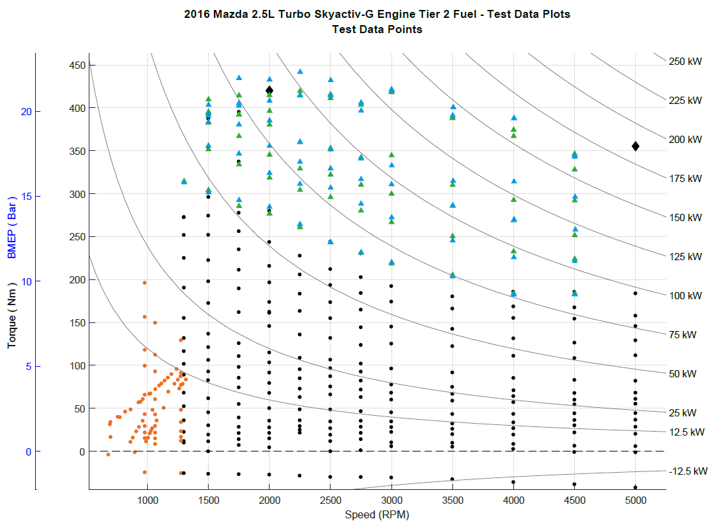
LEGEND
Core Map Steady-State Operating Points
(engine coupled to dyno, no transmission)
Low Speed/Near Idle Steady-State Operating Points
(engine coupled to transmission)
High Load Transient Operating Points - Initial Value
High Load Transient Operating Points - Final Value
Maximum Torque points (from published data)
Figure 4. Three Load Regions and the Associated Engine Mapping Operating Points

Steady State- The core map steady-state operating points, the black dots in Figure 4, are collected using steady state mapping procedures and are below where enrichment was first observed in this benchmarking program. These points generally have stable consistent engine controls (e.g. spark timing, valve timing, start of injection), allow the use of relatively slow response fuel flow measurement systems over a 30-second data collection window, and are therefore straightforward to analyze and report.

High Load Transient- The high load transient operating points, the blue and green triangles in Figure 4, are defined as the region where enrichment is observed. Data cannot be collected with steady state procedures due to the transient nature of the engine control, which is employed to protect the engine from excessively high temperatures, avoid preignition at low speed/high load, or avoid knock at high speed/high load. The ECU avoids these damaging effects by transiently adjusting the engine control parameters to lower temperatures, often at the expense of fuel consumption and efficiency, through control techniques such as spark retard and fuel enrichment. To properly benchmark the engine and monitor its changing control and performance in the high load region, a transient test procedure is required. Characterization of the engine’s transient behavior at high load is most important when creating engine fuel maps which can be used to estimate “off-cycle” emissions that occur when the vehicle is operated above power levels needed over the regulatory certification cycles (FTP, Highway, and US06).

Low Speed/Near Idle- Test data for engine operating points in the Low Speed/Near Idle region that are at low speeds or near and at idle conditions, the orange dots in Figure 4, cannot be collected acceptably with the direct coupling arrangement of the engine to the dynamometer typically used for mid and high load testing due to the high torsional stiffness of the driveshaft and the high rotational inertia of the dynamometer. Gathering data in the low speed/low torque area of the engine map is accomplished by incorporating a transmission (automatic) into the test setup producing driveline behavior similar to that found in the vehicle.

Benchmarking Details
To gather the complete set of test data shown in Figure 4, the engine was operated with and without the transmission in the three key Test Phases identified in Table 7. Each different test phase is discussed in more detail to explain how each of the various types of data were measured and processed to develop a complete fuel efficiency map suitable for use in a full vehicle simulation model such as ALPHA.
Table 7: Summary of the Engine Benchmarking Methods and Procedures
Test Phase | Engine Operation | Data Collection | Data Processing
1 Low-Mid Loading | 30 sec avg.  (Stoichiometric) | Steady-State (without transmission) | Steady-State Average  (using iTest)
2 High Loading | Stab test (Stoich.Enriched) | Transient  (without transmission) | Transient Intervals  (using Matlab)
3 Idle-Low Loading | 30 sec avg.  (Stoichiometric) | Steady-State  (with transmission) | Steady-State Average  (using iTest)

Test Phase 1: Low-Mid Loading
To collect the core map steady-state operating points (black dots) in Figure 4, the engine is configured without its transmission and tested in steady-state operation at low to mid loads where the air/fuel ratio remains stoichiometric at speeds from 1000 to 5000 rpm using the steady-state data collection and steady-state processing with the iTest system. Data points for the low-mid load region (black dots) are typically collected first during the engine benchmarking process because these samples help ensure the engine is setup correctly with no unexpected resonance frequencies, is operating within acceptable temperature ranges, and is tethered appropriately so the OBD II system is not showing current or pending malfunction codes. The engine to dynamometer setup for this portion of the benchmarking is faster since the transmission of the vehicle is not yet needed.
Engine Operation – For this phase of testing the engine is operated using a test procedure to appropriately characterize steady-state engine operation at low/mid loads. The core of the steady state engine map contains the primary operating range of the engine, which is characterized by stoichiometric operation and spark timing which will result in the highest efficiency. The stability and repeatability of engine operation in this load region allows for straightforward collection of steady state measurements on an engine dynamometer.
Data Collection – Engine operation consists of holding the engine at a fixed speed (with the engine dynamometer) and commanding a fixed pedal position. Operation at this point is held until the engine torque, fuel flow, and exhaust temperature reach a stable condition. The data are then logged for 10 seconds at 10 hertz sampling and averaged using iTest. For each engine speed, the sequencing procedure steps through an array of pedal commands from low to high (0 to 100% pedal position) and records the steady-state data for each test point. The engine speed is then incremented to the next highest rpm and the torque array is repeated. Generally, mapping points are denser in the lower engine speeds and loads areas of operation.

Test Phase 2: High Loading
To collect the high load transient operating points (blue and green triangles) in Figure 4, the engine is configured without its transmission and tested in transient operation at high loads where the air/fuel ratio transitions to enriched to protect the engine at speeds of 1000 to 5000 rpm using the transient data collection procedure and the initial-final interval post-processing. Data points for the high load region are gathered in this phase of the benchmarking which pushes the engine to operate at its highest torque levels across all engine speeds. No transmission is used in the engine-dynamometer setup for this phase of testing.
When operating in high load conditions, the engine ECU controls several parameters such as air/fuel ratio and spark timing differently depending upon the speed and load on the upper limits of the engine performance. Generally, engines operate at a stable stoichiometric air/fuel ratio idle to approximately 70% load. Above 70% load, the engine ECU will transition the air/fuel ratio from stoichiometric to enriched as needed to protect the engine from excessive heat.
Engine Operation - For this phase of testing the engine is operated at high loads near and including wide-open throttle (WOT) using a special test procedure to activate the transient response that occurs when the engine is protecting itself at high loads. While NCAT has successfully used a sweep test in some previous test programs to establish the maximum torque curve used for simulation, our experience with naturally aspirated and turbocharged gasoline engines tells us that sweep tests often under-predict the maximum achievable torque of the engine. This is primarily due to the high temperatures resulting from the relatively slow rpm sweep (5-10 seconds) and the subsequent de-rating due to engine protection controls. For this reason, NCAT ran the high load transient procedure to determine WOT and used the sweep test to better understand protection controls and to potentially fill in some data gaps for the lower speed range of the WOT curve.

The minimum high load points are identified during the steady state testing done in Test Phase 1, when the air/fuel ratio is noted to change from stoichiometric to enriched during its stability and steady-state logging time period of approximately 30 seconds. For each transient test point, the accelerator pedal is held at about 1/3 load and the engine is allowed to stabilize. The accelerator pedal is then ramped at a programmed one second rate to the desired torque for that test point (NCAT refers to this portion as the “stab test”). This engine operating condition is maintained until a time limit is reached. The engine is stepped through an array of specified speed and load points in a sequence similar to the steady state procedure.
Data Collection – For each data point, the data are logged continuously at 100 Hz while the engine torque is ramping up to the desired torque value and while operation is held at that point for 30 seconds. The data are then post-processed to determine the peak torque, final torque, transition time from stoichiometric to enriched, brake thermal efficiency (BTE), and other key engine criteria.

Determination of Initial and Final Intervals for Post-Processing of Transient Data Points – Once the roughly 30 seconds of transient data have been collected for the high load points, the captured data streams must be post-processed to determine the final results. These results will be used later to develop brake specific fuel consumption (BSFC) and brake thermal efficiency (BTE) maps suitable for use in vehicle simulation models. The basic calculations for transient data points include a straight-forward averaging of repeat measurements.

To characterize the high load region of operation, the goal was to define an “initial” time window after the target high load torque is achieved and then a “final” time window after control stabilizes to a long-term steady state value. Once the two intervals are determined, the data are then computed as the straight-forward average of the measurements in the interval. The average values in these two intervals bookend operation in the high load region.

Within the data set, the windows are determined based upon an initial time, t₀, when the engine achieves the target torque value. The blue torque line in the top chart of Figure 5 illustrates the engine torque achieving ~350 Nm. The initial high load interval, the blue highlighted area in Figure 5, captures the region of maximum torque within 2 seconds following t₀.

The final high load interval, the green highlighted area in Figure 5, contains the stable torque and fuel consumption data measurements representing how the engine operates when it stays at that high load data point for a sustained period of time. The final high load interval begins when the torque and fuel flow meter measurements become stable (although no earlier than 2 seconds after t₀) and ends at the end of the data stream’s sample of stable operation.

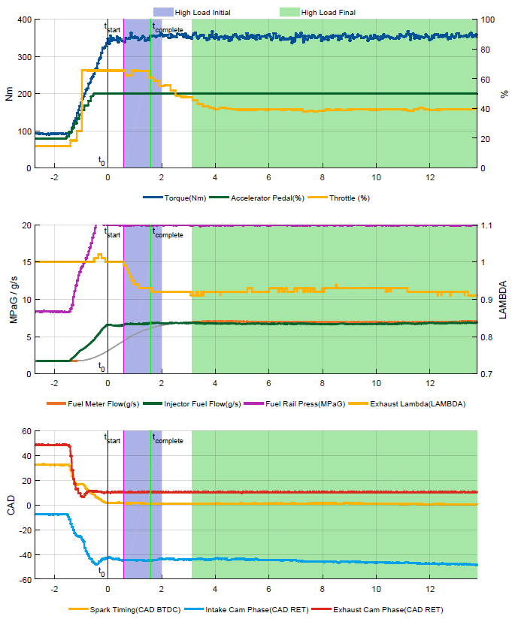
Figure 5. Example High Load Test Showing Several Pertinent Parameters and the Windows of Data Selected (2500 rpm, 350 N-M)

Special Measurement of Fuel Consumption During Transient Operation

Typically, when benchmarking an engine, steady-state operation allows for the straightforward measurement of fuel consumption either by a fuel flow meter or by exhaust emissions. NCAT generally uses a fuel flow meter when benchmarking engines. Due to transport lag and other time delays, these two measurement techniques are unable to accurately quantify the amounts of fuel consumed over short periods of engine operation. Consequently, NCAT uses a third technique that uses fuel injector data to measure how much fuel is consumed.

By capturing detailed measurements of fuel injector pulse duration and fuel rail pressure during steady state testing, an injector calibration can be constructed to then estimate fuel consumption. For improved accuracy, the fuel rail pressure is measured via a high-speed data acquisition system synchronously with the crankshaft to minimize the distortion caused by rapid fluctuations in pressure.

The method of injector fuel flow correlation that was developed for this testing is shown in the equation below. The relationship between fuel rail pressure, injection duration and injected fuel quantity for a single injection event follows from the classic orifice equation.

$$q_{fuel}=m∙\left(\sqrt{P_{rail}}∙{dur}_{inj}\right)+b$$
Where: $q_{fuel}$ = injected fuel quantity (mg)
$P_{rail}$ = High pressure fuel rail pressure (MPa)
${dur}_{inj}$ = Injector open duration (ms)

The calibration constants m (slope) and b (offset) can be determined via linear regression. Figure 6 below provides an example of the relationship using data obtained during testing.

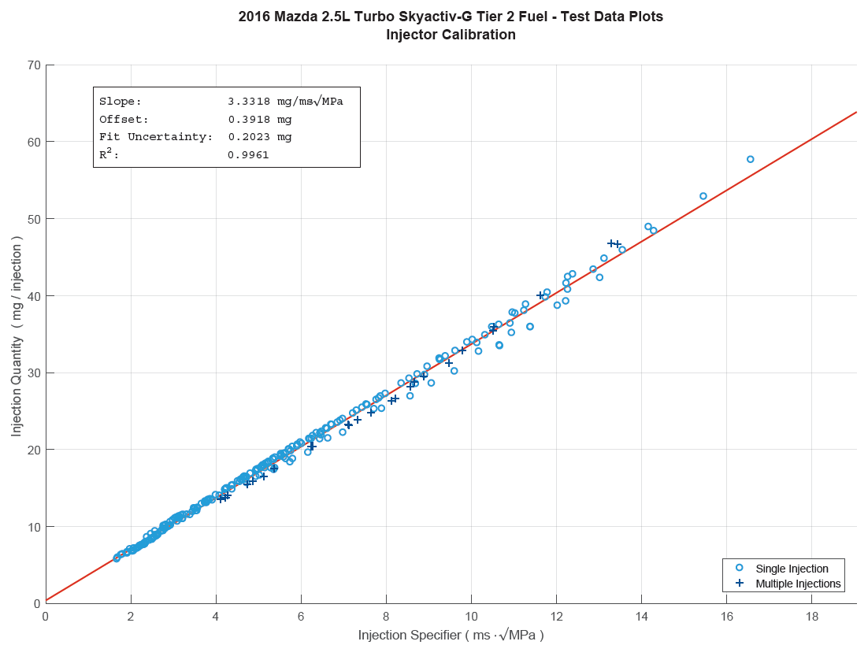
Figure 6. Fuel Flow Correlation

Test Phase 3: Idle-Low Speed
Data points for the idle-low speed region of engine operation, shown as orange dots in Figure 4, are gathered in this phase of the engine benchmarking by coupling the engine with a transmission and torque converter to the dynamometer. This region of engine operation will have problems associated with high torsional accelerations if coupled directly to the dyno. The transmission with a torque converter dampens these accelerations and lets the engine operate normally.

Engine and Transmission Operation: Testing in the idle-low speed region of the map is conducted by operating the engine with the transmission in drive and the torque converter in either a locked or unlocked condition. The data points at the idle and lower speeds are conducted with the torque converter unlocked. The data points at the high speeds and loads are conducted with the torque converter locked and the dyno controlling engine speed. The engine load for both conditions is controlled by the pedal command. The data are collected using the steady state method.

Data Collection – The test procedures for testing in this region require the engine operation at each point the pedal position is held until the engine torque, fuel flow, and exhaust temperature stabilize for approximately 30 seconds. Data are then collected at 10 Hz for 10 seconds.

Data Quality Control
A test parameter subset of data focused on engine efficiency was extracted from the iTest data log for review. Descriptions for the test parameter list are provided in the test data set for reference. The data set is analyzed for outlier data based on the statistical data included in the iTest data logger file. In addition, the data set is plotted and reviewed using an NCAT developed contour plotting routine. During these reviews, any outliers may be removed as needed based upon the discretion of the internal review team.

Results
The final test data set containing the engine mapping test parameters is provided in the file: 4-2016 Mazda 2.5L Turbo Skyactiv-G Engine Tier 2 Fuel - Test Data. The average torque, speed, and fuel flow measurements were used to determine a grid and generate fuel contour maps for Brake Specific Fuel Consumption (BSFC), shown in Figure 7, and Brake Thermal Efficiency (BTE), shown in Figure 8. Additional contour maps for the remaining test data measurements are provided in 5- 2016 Mazda 2.5L Turbo Skyactiv-G Engine Tier 2 Fuel - Test Data Plots.pdf.

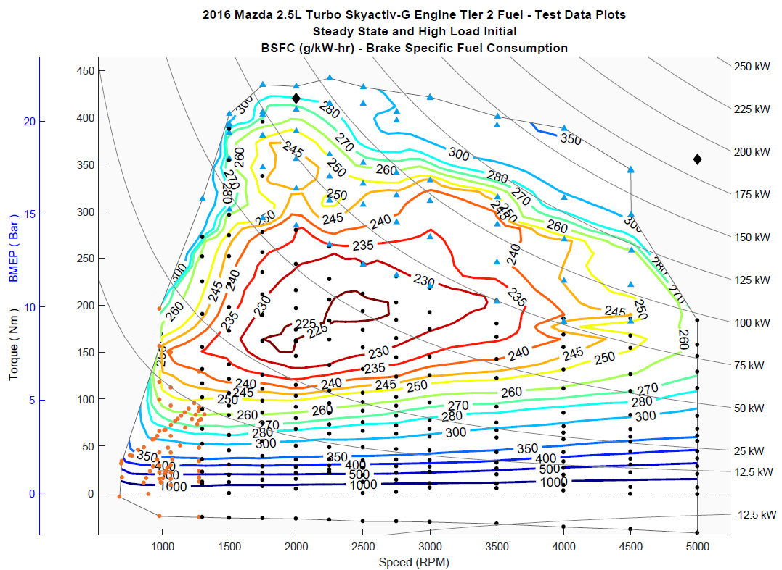
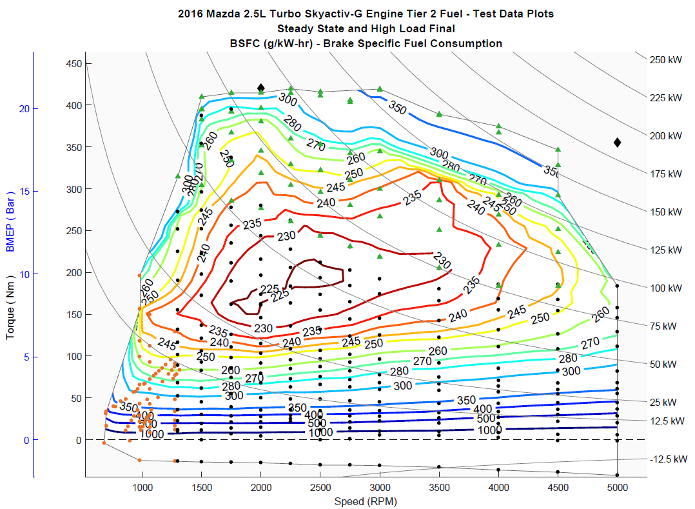
Figure 7. BSFC in the Initial and Final Intervals
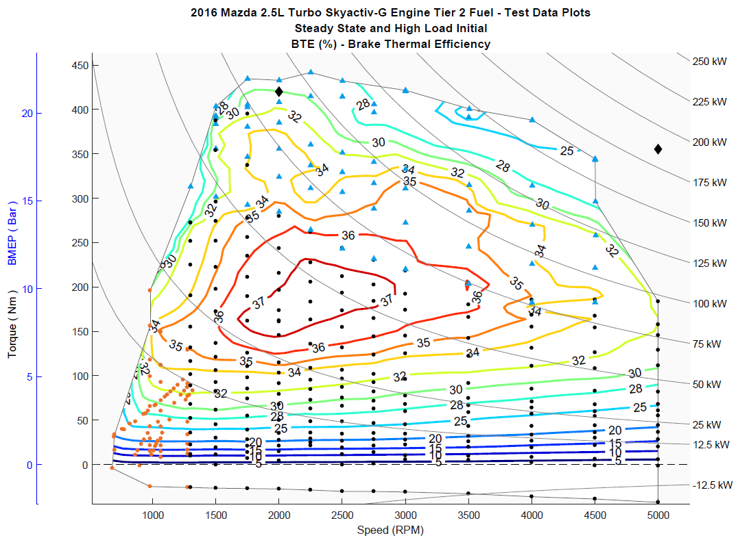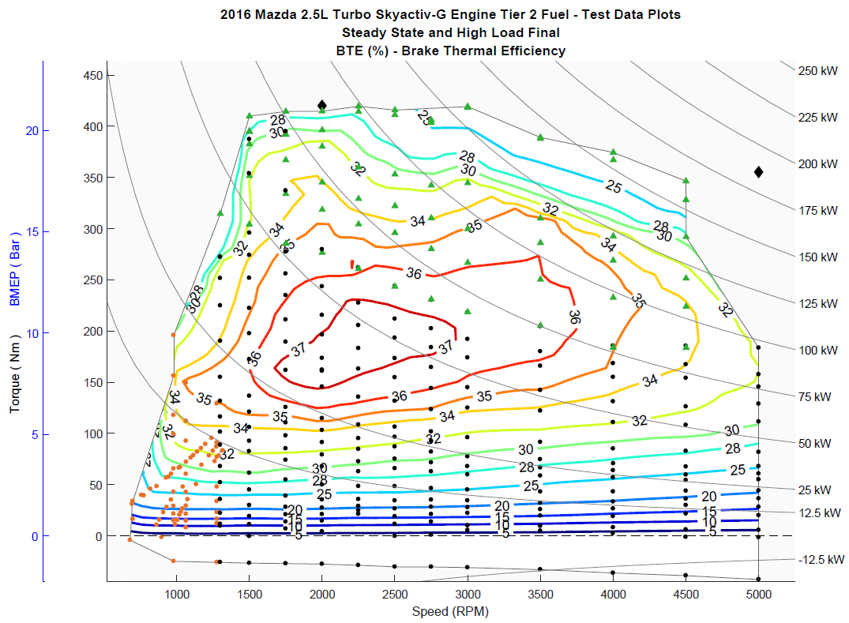
Figure 8. BTE in the Initial and Final Intervals

Uncertainty

Sensor/signal uncertainties
The uncertainties of the signals [u(signal)] in the data set can be based on (a) the uncertainty associated with the calibration standard, (b) the uncertainty of the sensor calibration [u(calibration)], and (c) the uncertainty of the signal during operation [u(operation)]. The uncertainty associated with the calibration standard is assumed to be negligible when compared to other uncertainties and thus this uncertainty is not considered for this calculation.

To determine the uncertainty of the sensor calibration, past calibration records were assessed and the difference between the standard and measured quantities were used to calculate uncertainty. If the sensor output and standard matched exactly, the uncertainty was assumed to be associated with the last digit of accuracy of the output. For example, the speed signal, which reads to the nearest rpm, was assumed to have an uncertainty no less than that of a uniform distribution of width = 1 rpm; i.e., 0.289 rpm.

In the special case of the fuel measurement during transient operation, where the injector calibration procedure was used to determine the final fuel flow, an additional term was added to account for the uncertainty associated with the fit uncertainty in the correlation (see Figure 6), which was 0.2023 mg per injection, or 6.74 E-6*(Engine rpm) in grams/sec.

To determine the uncertainty of the signal during operation, the standard deviations for each signal were recorded for speed, torque, and fuel flow as each mode was taken. From this, the uncertainty was calculated as
$u=σ/{\sqrt{n}}$
Where n is the number of individual data points averaged to create the mode. Raw data are nominally read once per engine cycle, so assuming a 30 second mode, n = (Engine rpm)/2.

Table 8 provides standard uncertainties for each signal. In the case of the operational uncertainty of the signals and the transient correlation (when applicable), the average values over the data set are given for reference. Within the data set, these uncertainties were calculated individually for each mode.

Table 8: Standard Uncertainties for Signals
Signal | u(calibration) | u(correlation) average (ref) | u(operation) average (ref) | u(signal)
Speed (rpm) | 0.998 | - | 0.0676 | 1.000
Torque (Nm) | 0.116 | - | 0.0519 | 0.127
Fuel (g/sec) - steady | 0.00240 | - | 0.000240 | 0.00241
Fuel (g/sec) - transient | 0.00240 | 0.0186 | 0.000240 | 0.0188

Testing uncertainty
In addition to the uncertainties associated with each signal, there may be an overall uncertainty associated with the repeatability of the testing procedure and the engine operation. To estimate this uncertainty, a number of common modes were run at 2000 rpm and 160 Nm (Figure 9), and the standard deviation of the resulting data calculated.

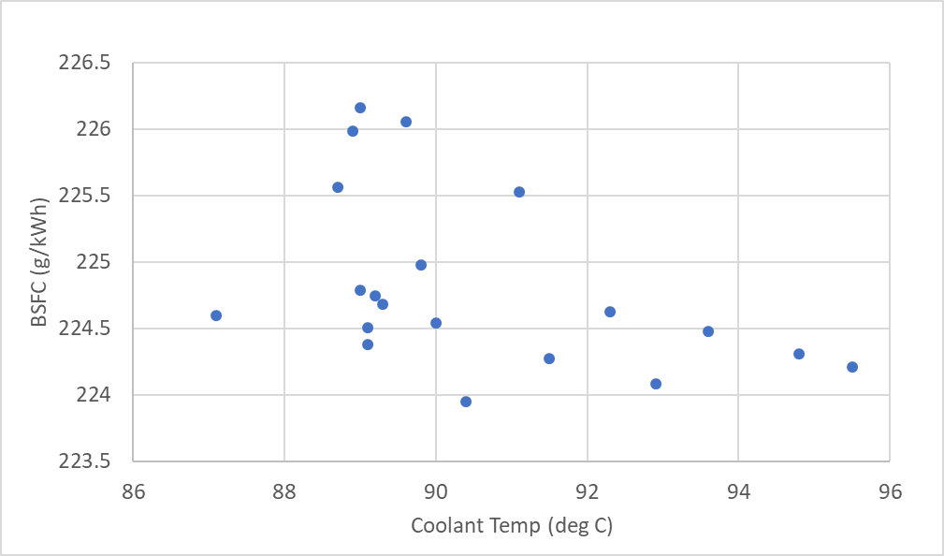
Figure 9. BSFC Variation of Common Modes
(plotted against coolant temperature for convenience)

The expected uncertainty at the 2000 rpm and 160 Nm, using the calibration and operational uncertainties from Table 8, is approximately 0.33 g/kWh BSFC (0.054% BTE). The standard deviation in the common mode data set was 0.67 g/kWh BSFC (0.111% BTE). To estimate the testing uncertainty associated with the repeatability of the testing procedure and the engine operation, the difference in uncertainty was calculated as u_{e}(BSFC) = sqrt(0.67² – 0.33²) = 0.59 /kWh, or u_{e}(EFF) = sqrt(0.111² – 0.054²) = 0.097% in efficiency. This magnitude of uncertainty can be used in the final uncertainty calculation below.

Uncertainty of BSFC
The variation of engine BSFC includes a testing uncertainty of 0.59 g/kWh, and is thus calculated by:

$$u\left(BSFC\right)= \sqrt{{\left(\frac{∂BSFC}{∂q}\right)}^{2}{\left[u\left(q\right)\right]}^{2}+{\left(\frac{∂BSFC}{∂T}\right)}^{2}{\left[u\left(T\right)\right]}^{2} +{\left(\frac{∂BSFC}{∂ω}\right)}^{2}{\left[u\left(ω\right)\right]}^{2} +{\left[u_{e}\left(BSFC\right)\right]}^{2}}$$
or
$$u\left(BSFC\right)= \sqrt{{BSFC}^{2}\left[{\left(\frac{u\left(q\right)}{q}\right)}^{2}+{\left(\frac{u\left(T\right)}{T}\right)}^{2}+{\left(\frac{u\left(ω\right)}{ω}\right)}^{2}\right]+{\left[u_{e}\left(BSFC\right)\right]}^{2}}$$

Uncertainty of BTE
The derivation of the uncertainty of thermal efficiency is similar, with a testing uncertainty of 0.097% efficiency. The uncertainty in measurement of the fuel heating value is assumed to be small compared to other uncertainties. Assuming u(HV) = 10 BTU/lb,

$$u\left(EFF\right)= \sqrt{{EFF}^{2}\left[{\left(\frac{u\left(q\right)}{q}\right)}^{2}+{\left(\frac{u\left(T\right)}{T}\right)}^{2}+{\left(\frac{u\left(ω\right)}{ω}\right)}^{2}+3.1*{10}^{-7}\right]+{\left[u_{e}\left(EFF\right)\right]}^{2}}$$

Standard uncertainties are analogous to standard deviations, such that it would be expected that, for a given set of data, the “true” value of a parameter would fall within +/-1u_{c} for 68% of the data points, the “true” value of a parameter would fall within +/-2u_{c} for 95% of the data points, and the “true” value of a parameter would fall within +/-3u_{c} for 99.7% of the data points. The calculated uncertainty for both the BSFC and BTE measurements are shown in Figures 10 and 11.

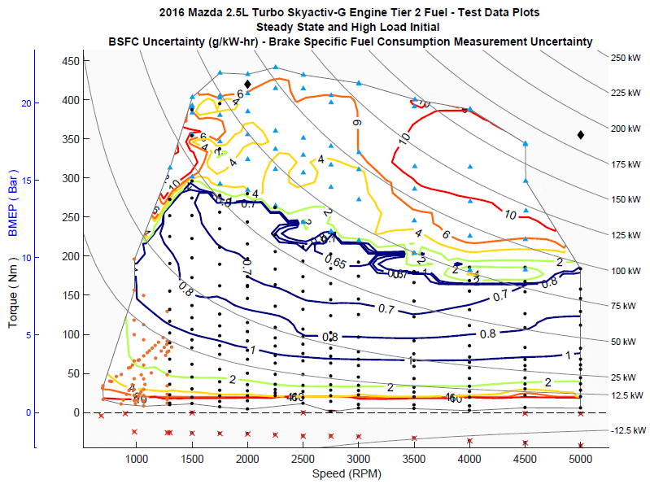
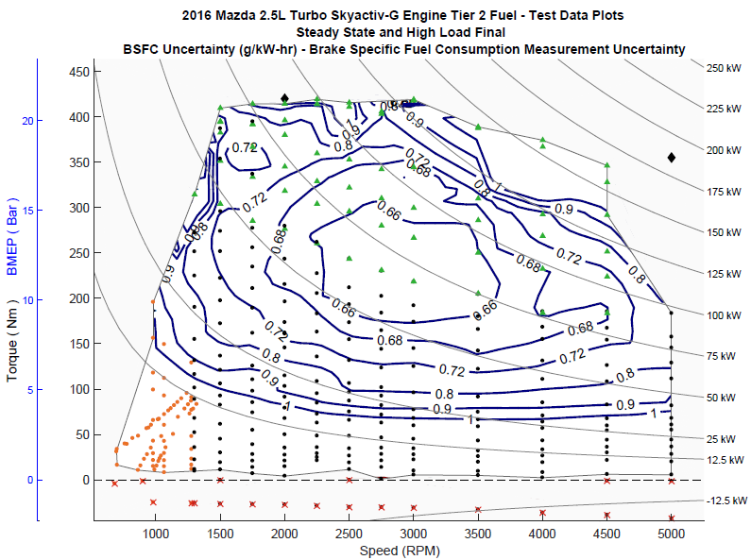
Figure 10. BSFC Uncertainty
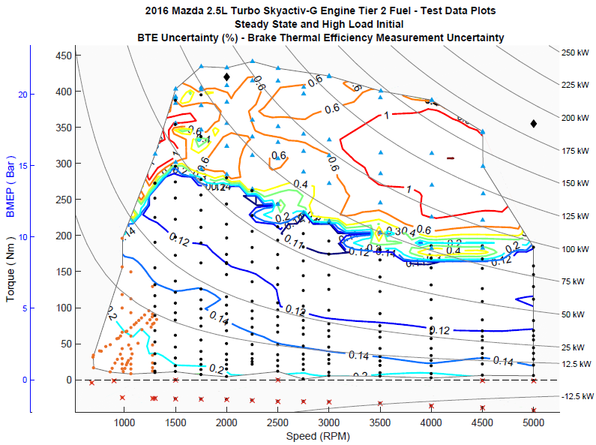
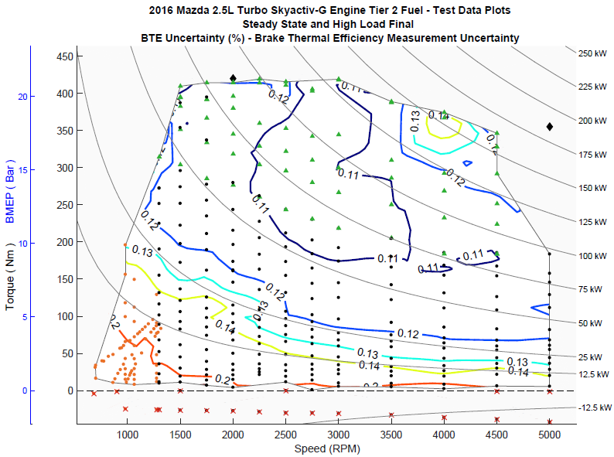
Figure 11. BTE Uncertainty
Users should note the uncertainties associated with the high load initial data can be quite large, shown by a few example values where the uncertainty is over 10 g/kWh BSFC (Figure 10). Figure 12 provides data from one of the highest uncertainty points which illustrates the two primary causes of this high uncertainty. The first is that the high load initial window is very short, meaning only a few data points were collected. Second, both the torque and fuel values fluctuate noticeably during this window and thus have high standard deviations. Although the final uncertainty values calculated from these test points seem reasonable when considering these factors, users of the data should exercise their own engineering judgment when using data having a high uncertainty.
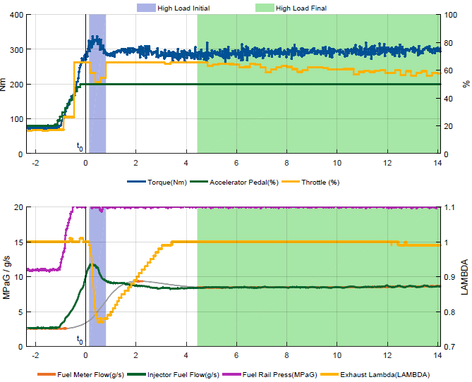
Figure 12. High Load Test at 4000 rpm, Showing the Windows of Data Selected

References
[1] Stuhldreher, M., Kim, Y., Kargul, J., Moskalik, A. et al., “Testing and Benchmarking a 2014 GM Silverado 6L80 Six Speed Automatic Transmission,” SAE Technical Paper 2017-01-5020, 2017, doi:10-4271/2017-01-5020.

[2] Mazda Service Manual - https://www.mazdaserviceinfo.com/login

